The Design City Map: A Tentative, Complete Mapping of Design

Martin Kofod Ludvigsen, PhD, associate professor
Aarhus School of Architecture, Department for Design, Center for Interactive Spaces
Martin.ludvigsen@aarch.dk

Design thinking has been propagated at an increasing intense way in the last few years, lately most prominently by the design company IDEO and CEO Tim Brown [1]. This notion of design thinking is interesting from the point of view of the designer, as this holds the potential of bringing how designers think and work closer to management and strategic, long-term decisions. As any other professional practice, design is interested in this potential rise in the organizational structures of influence, especially if it is based on a profound appreciation of how designers think, how situations are approached, how problems are solved and decisions are made.
This paper seeks to make a tentative map – a sketch – of how designers think and act - integrating some of the basic distinctions in design: an intrinsic empathic attitude to other people and an appreciation of objective material qualities, as well as a continuous oscillation between strict, linear logic and hermeneutic, integral or aesthetic reasoning. This mapping is presented as an attempt to draw out possible interfaces between design and management by describing how designers think, as seen from design, in order to understand design thinking. If a similar mapping could be made of management, maybe the mysterious veil of that field would also be made transparent to designers. The simplistic way of mapping out all design in one generalizing sweep is probably provocative to some, especially to designers who do not want to be easily cornered in a given form, and of course such a mapping disregards precious details in order to achieve a fuller view. Design thinking offers a holistic approach to strategic development that holds an interesting promise to management, and as such presents us with new and important research challenges on the border between design and management. The map will point to some of these challenges.
Logic and Aesthetic
In order to appreciate the full extend of design one should not limit the extent of design by choosing a particular strand or type of design as the “right” or “true” kind of design. There has always been – and will always be – a disagreement between designers who are more artistically or technically oriented, those who sees the commercial market as the prime ground for design or those who are preoccupied with culture in general. Or, similarly, with the cavernously deep differences between the designers working with graphics and objects of beauty and those working with systems in IT or organizations. There is no reasonable way to give precedence to one of these types of design. Far more interesting knowledge would come from trying to put them into an integrated overview of the differences in design and the thinking behind it.
The first and most evident axis I want to include in this mapping is that of design thinking: the cultural backdrop of the designer and the fundamental way the designer decides to know about things. At one end of this axis we have the traditional engineer and technically oriented designer. Here the design process is more or less a linear model with a range of logic steps and logic decisions following each other. The design process is completely transparent and the tools are well-documented and described. At the other end we have what I am calling the aesthetic thinking as opposed to logic thinking. The aesthetic connotes a more artistic and inspired approach to the design process where the very personal process of the designer is defining the outcome. This resembles Fällmans [2] definitions of engineering design as opposed to black-box design with the third account of pragmatic design positioned in between them combining the subjective approach of the artist-designer with the transparency and collaborative approach of the engineer-designer. However, the two extreme positions are interesting for spanning an axis onto which design thinking can be rated as to how much they rely on aesthetic or logic thinking in their process approach.
The notion of aesthetic actually has its roots some centuries back when Alexander Baumgarten coined the term in a doctoral thesis in 1732 [3]. He was intrigued by the incredible success of the new scientific discoveries of this time and the promise of scientific and logic thinking to uncover and know everything. However, as described by Kjørup, he saw a problem in the fact that logic knowledge could come to one right answer to anything, yet there still existed things in the world of man that could not be described that simple or be known in such unambiguous way. You can describe, say, a building completely if you are able to completely describe every component and material. But the same could not be done with love or a beautiful view of a landscape. Yet we can still know about these things and convey the experience of them. Baumgarten coined aesthetics to mean sensitive knowing as opposed to abstract, scientific, logic knowing. We do not have only one path of discovery or enlightenment where concepts are divided into the lower obscure and the higher complete concepts in a logic or philosophic clarity, but we have also this other path from the obscure concept toward clarity in a sensitive discovery. So where the traditional continuum takes the obscure concept towards a higher degree of intensive clarity and completeness, Baumgarten introduces the notion of extensive clarity. “Whereas the increasing intensive clarity can be said to go in depth, and thus become increasingly abstract, the extensive clarity can be said to go in horizontal width and thus become more and more concrete” [3]p.51.
The term aesthetic is problematic as it is used in a wide field of other academic and artistic endeavors, but I think it works well in this mapping to construct the opposition of two ways of thinking designerly. Several other terms have been constructed to emphasize this difference e.g. [4] yet I find it fruitful to look at the core of the two camps to find the cause of the divergence.
The difference between logic thinking and aesthetic thinking is not a distinction between ‘new’ and ‘old’ school design thinking. It is a cultural distinction that has been around for years. The logic approach is the most accepted in the world of business as certainty and scientific rigor is often at the backbone of organizations and the decisions that are made in the organization. The logic approach is verifiable, based on facts and figures, whereas the aesthetic approach is fundamentally relying of experience and trust. Logic thinking relies on inductive and deductive processes, whereas aesthetic thinking allows abductive reasoning [5] into the process. Both types of thinking are probably needed in most organizations – especially in the process of creating a strategic path - and definitely in any design process. The professional designer will work through the spectrum from rigorous analysis and data gathering to gut-feeling explorations and subjective sketching processes. Combined I suggest that logic and aesthetic represent a spectrum or axis of design thinking usable for understanding – and interfacing with – designers.
Material and Context
But design thinking is only half of design. The other component is design doing. Here I have resorted to two general areas of innovative action that designers use to discover the new. As Tim Brown [1] emphasizes, along side many others in the ongoing debate on design thinking, the core of a good design process is understanding the people and the context you are designing for on one hand, and on the other have a deep understanding of the material you are designing with – a mastery of some concrete form with which you can test ideas and make prototypes.
This axis of design doing is essentially a spectrum of ‘asking’ whereas the previous was an axis of ‘knowing’. Designers work with problems and challenges in open ways with a dedicated focus on the future – on possible solutions of a design question. Because design is about future solutions it is a process of discovery and the designer starts from a position of ‘not-knowing’ working their way towards a possible answer. In this process of design doing the designer asks either the context what is desirable, feasible, viable or asks the ‘material’ what is likewise desirable in terms of expression of form or graphics, feasible in terms of material quality and production methods, viable in terms of cost etc.
‘Material’ can be defined as whatever carries the design, or what the designer can manipulate in order to communicate with a user or recipient of the design. Most often the designer works on a model of the actual product and is prototyping his way through several possible solutions in order to find the best. A designer is often very specialized in one or two particular types of material and has a master level of craftsmanship with manipulating the material to convey different messages and experiences. This material aspect of design is often overlooked when talking about the new edge of design and design thinking since it is difficult to define a distinct material of management or organization. However, I believe firstly that there is such a thing as a material of high-level strategic design, namely the material of the organization itself; people, processes, values and visions, and, secondly, that the craftsmanship aspect of mastery is an important component of the execution of design thinking.
’Context’ at the other end of this spectrum is where we have seen a plethora of new initiatives and design work being done in recent years, e.g. [6,7]. Understanding and involving users and stakeholder in every level of the design process is a fundamental way of securing a desirable outcome of the developmental work. Starting from the roots in participatory design in the early 80’s [8] in system development and with a widespread incorporation of ethnographic methods into the design process, contextual knowledge must play an important role in any design process. Today many designers are specializing in this type of design work and intentionally dissolving the difference between creator and receiver of design and using contextual skills to move design work into new domains and types of design projects.
Both types of ‘asking’ activities should be seen in the context of the basic design process, where every attempt at a solution is tried and tested up against the knowledge of the present. In trying to work out a ‘wicked problem’ [9] the designer needs to jump the hermeneutical gap [10] into a future state with whatever means of representation the communication of this state requires, and then work his way back from the future towards the present. This sketching approach is meant to keep ideas in a liquid state [11] with several possible solutions juxta-positioned and influencing each other towards a resolution.
With these four directions of the design mapping in place the overall diagram looks somewhat like this (fig. 1).
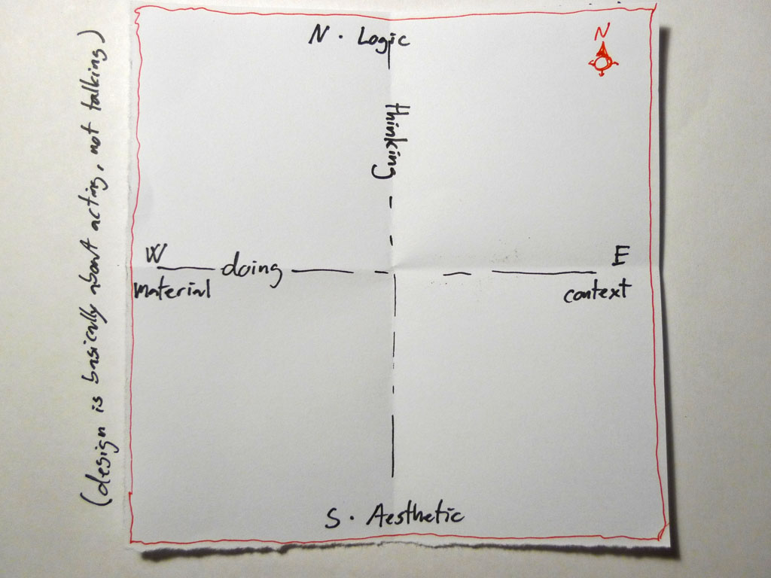
Figure 1: The interrelated four design positions
We have the beginning of the mapping, as we now have four distinct camps of design, from where designers could battle to find out who is the ’right’ kind of designer: the subjective artist, the strict engineer, the user-oriented innovator and the material explorer. With these four epistemological directions we can also describe the four quadrants they outline: circumscribed by context and logic, linear thinking we have the designer focusing on market in the upper right quadrant. Below the designer works with an aesthetic perspective and focusing on the context of use and reception of the design the designers focus is on the meaning and cultural implications of the design. Between the material and logic perspectives, upper left, the designer is focusing on form in terms of production, whereas the designer with a material focus and a fundamentally aesthetic approach looks at the artifact and form in terms of expression as an artistic challenge.
Placements
However, there is still one obvious range of distinction within design that should be included in order to capture the new edge of design and the ”interface” towards management - namely the type of design being done. For this purpose I will use Buchanan’s concept of placements [12]. One of the prime qualities of design is that it takes place in so many forms, in so many fields and in so many ways. In recent years designers have been talking of an expansion of the notion of design as a way of describing the new edge of design, where design mixes with strategy, politics, art and experience economy. Richard Buchanan explains this new edge of design in relation to the classic genres of design; graphic and product design in terms of placements [12]. Placements are those design spaces or solution spaces in which a designer finds his solution to a given design problem. The classic placements are graphic design and product design. Here designers’ understanding of the solution is that it will take the form of a graphic symbol or other 2-dimensional form, or a 3-dimensional thing that can be handled and experienced in a physical form. Over the course of the last couple of decades we have seen the emergence of interaction design as the third placement where the design can take the form of an interactive product, service or experience. Buchanan further suggests a fourth placements of system, where the distinct is that an action in the third placement can be directly experienced by the recipient of the design whereas a system cannot, as it entails designing the overall system of thought that shapes how we act in relation to the designed. The designed system can only be experienced in its application of a particular instance of a service, object or graphic representation – not in its entirety. Just as with organizations and strategies.
The notion of placements is interesting as it gives us – again – distinctions of types of design. These can be related to each other, not just, as suggested by Buchanan, as equal areas of invention, but also as a nested hierarchy going from graphic to product to interaction to system. This is NOT a hierarchy of importance or complexity delineating interaction design as better or more difficult than graphic design. Each of the placements has its own complexities and areas of expertise into which one can be a master. The nested hierarchy as shown in the final sketch of the design mapping (fig. 2) tries to depict a distinction of the level of wickedness [9] built into the design challenge, as designing a new logo or stationary for a corporation is less of a wicked problem than creating a service where a user needs to understand and interact with the service over time. Each of the four placements or orders of design [13] also implies an increase in the abstraction in representation: the graphic designer works almost directly with what will be reproduced, the product designer will work with a model in physical form or in sketches, the interaction designer will use scenarios and video to show development over time and the system designer will resort to diagrams showing interrelated parts and infrastructures influencing each other at high level.

Mapping out most of that
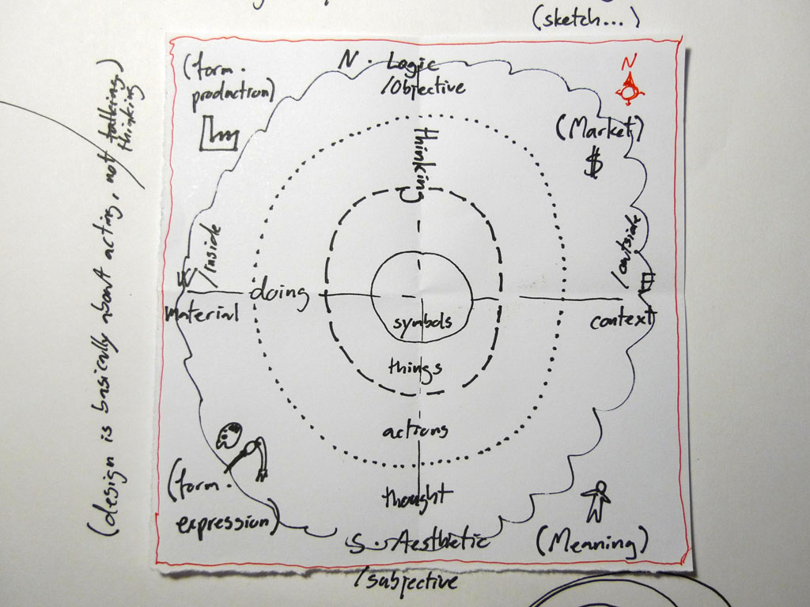
Figure 2: The Design City Map: the complete mapping of design thinking and doing

The map is meant to be the whole picture of design – a complete mapping. This is of course impossible to achieve, and there are several problems with the mapping, some of which I will address below. However, creating a map that sheds light on the interrelation of the dominating types and ‘camps’ of design helps us to understand the different aspects of design thinking and appreciate these qualities in relation to the overall picture. The problem in design, which might be inherited into management as design thinking is adapted wider outside the design community, is that each direction and each placement are cultures within themselves each with an appreciative system of their own [14]. This might then lead to unproductive misunderstandings between various positions on the map, when it should lead to a larger understanding and integration of differences.
  - City Map
The main problem of the mapping is that if understood as a coordinate system one would expect higher value to be ascribed to extreme positions making system design better than graphic design. This is not the case. The mapping should be read more like a city map where the center maps an area with different qualities than the outer rim – the suburban areas. There is no intrinsic value in being more eastern or northern than another position on an ordinary map, and the same goes for the Design City Map. Furthermore, the farther we move away from the center the more the designers need to mix their expertise with other professions and the more the design work and product start to look like those of other professions - e.g. management and business development. This resembles the move from city center to urban sprawl.
  - Management and design thinking
This mapping is meant to uncover a possible interface between design and management as seen from within the design field. Design thinking – understood as strategic design – interfaces with more traditional types of design at the level of systems design in the fourth order or placement of design. The role of design thinking in management as propagated by e.g. Tim Brown in [1] is to broaden the focus of traditional management and business development focus to included other ways of developing ideas than just a linear process and emphasizing a holistic, integral, sensual or what I am calling an aesthetic kind of thinking: Using methods from design as prototyping – making material tests of possible ideas in order to generate knowledge, and using observation and participation of real users in the developmental process in order to create meaningful products, services and systems for future business opportunities. Both are efforts to establish an alternative position to the traditional logic and ‘scientific’ position and introduce another way of discovering innovative ideas.
Conclusion
With the presented mapping I seek to present a tentative overview of design that should uncover a possible interface between design and management as seen from within the design field. Hopefully it is a good map that reaches enough detail and interrelations to make it useful for navigating and positioning oneself, while maintaining enough overview to make out the general territory.
As a pointer forward the map extends a way of understanding different approaches to design and different appreciative systems and cultures of design making it a starting point for exploring various disciplinary mindsets at work in the new fourth order of design at the systemic level, where design and management meet. This exploration is something I will pursue in coming research projects as a way of uncovering the interdisciplinary challenges in strategic design and using design thinking in organizational and management processes.

References
- Brown, T., (2009) Change by Design: How Design Thinking Transforms Organizations and Inspires Innovation, HarperBusiness
- Fällman, D. (2003). Design-oriented human-computer interaction. Proceedings of the SIGCHI conference on Human factors in computing systems. Ft. Lauderdale, Florida, USA
- Kjørup, S. (1999). Baumgarten og den sensitive erkendelse (in Danish), (transl. Baumgarten and the sensitive epistemology) Æstetik og logik (Aesthetic and Logic). J. H. (eds.). Copenhagen, Medusa: pp 41-60.
- Martin, Roger. (2007). The opposable mind: How successful leaders win through Integrative Thinking. Watertown, MA: Harvard Business School Press.
- Peirce, C. S. (1958). The Collected Papers of Charles Sanders Peirce, Vols. VII-VIII, Edited by AW Burks. Cambridge, MA: Harvard.
- Brugerdreven innovation, http://www.ebst.dk/brugerdreveninnovation.dk/forside/0/2, (accessed 03-12-2009)
- Buchenau, M., Suri, J.F., Experience prototyping, Proceedings of the conference on Designing interactive systems: processes, practices, methods, and techniques, August 17-19, 2000, New York City
- Ehn, P., Kyng, M., (1992) Cardboard computers: mocking-it-up or hands-on the future, Design at work: cooperative design of computer systems, Lawrence Erlbaum Associates, Inc., Mahwah, NJ,
- Rittel, H., W. J. and M. M. Webber (1973). "Dilemmas in a General Theory of Planning." Policy Sciences 4(1): pp. 155-169.
- Hallnäs, L. and J. Redström (2006). Interaction Design: Foundations, Experiments. Borås, Interactive Institue, University College of Borås.
- Boland, R., Collopy, F., Lyytinen, K., Yoo, Y., (2008). Managing as designing: Lessons for organization leaders from the design practice of Frank O. Gehry. Design Issues 24(1): 10-25.
- Buchanan, R. (1995). Wicked Problems in Design Thinking. The Idea of Design. V. Margolin and R. Buchanan. Cambridge, MA, USA, MIT Press.
- Buchanan, R. (2001). "Design research and the new learning." Design Issues 17(4): 3-23
- Schön, D. A. (1983). The Reflective Practitioner: How Professionals Think in Action, Basic Books.

